**Introduction**

1. Despite widespread use of count and binary outcome models, very few (lit search results) researchers report model results in terms of the quantities they set out to understand. In count models, this entails predicted counts, and in binary outcome models, this entails projecting predicted probabilities of an event occurring.
   1. We advocate for presenting quantities of interest directly, as models are readily able to output direct predictions of these quantities.
   2. Thoughtful graphical and tabular presentation of data can facilitate intuition even when models are complicated, and present a richer source of information than single parameters.

**Interpretation of single coefficients does not capture model effects well**

1. In examining predicted counts and probabilities, it becomes apparent that the single parameters reported in GzLMs do not map onto relationships between predictors and outcomes as readily as they seem to.
   1. In fact, further analysis of these parameters reveals that even their transformed versions, such as odds ratios and rate ratios, a) do not represent constant first differences, and b) do not represent effects that are conditionally independent from one another, as in OLS linear regression.
   2. To show that these two properties hold for binary outcome and count models, we present a simulated-data example with two predictors for each model below.

**Binary Outcome Models**

Logistic Regression

[Math showing effect of X1 is not independent of level of X2]

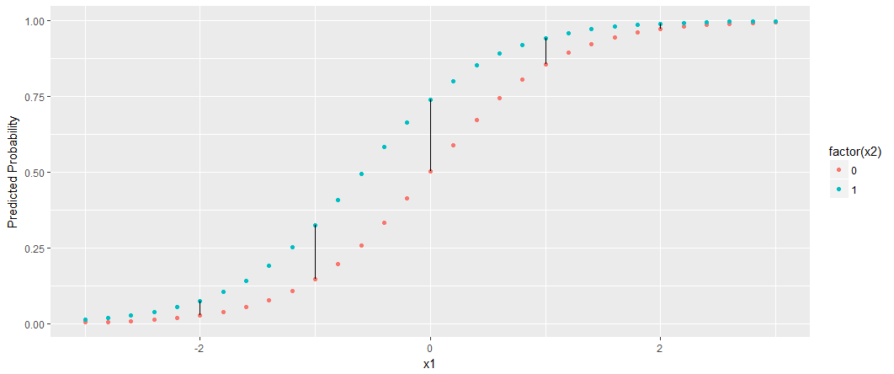

**Count Models**

Poisson Regression

[Math showing effect of X1 is not independent of level of X2]

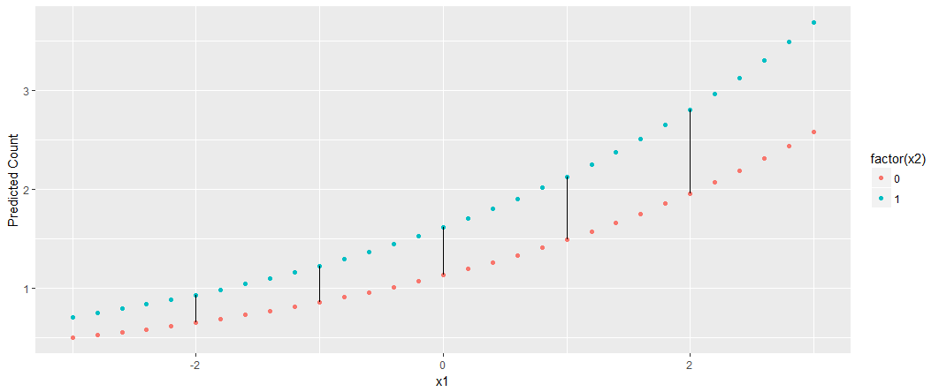

Negative Binomial Regression

[Math showing effect of X1 is not independent of level of X2]

Zero-inflated Models

[Math showing effect of X1 is not independent of level of X2]

Hurdle Models

[Math showing effect of X1 is not independent of level of X2]

1. When presenting results, is important to recall that the choice of covariate levels chosen as 0 values can influence the interpretation of results to the majority of readers, who do not have time to probe a model fully.
   1. We propose that research producers should choose their covariate values thoughtfully.
   2. In order to characterize an effect accurately, researchers may have to probe an effect at multiple covariate levels, even when no interactions are included in the model.

***Recommendations for presentation of models: tables and graphics***

**Binary Outcome Data**

Table of first differences *with* covariate values made explicit

Graphic of first differences for some X1 and X2 of interest

Real data example???

Show graphs from InterActive? With uncertainty.

**Count Data**

Table of first differences *with* covariate values made explicit

Graphic of first differences for some X1 and X2 of interest

Real data example???

1 Ai, C., & Norton, E. C. (2003). Interaction terms in logit and probit models. *Economics letters*, *80*(1), 123-129.

2 King, G., Tomz, M., & Wittenberg, J. (2000). Making the most of statistical analyses: Improving interpretation and presentation. *American journal of political science*, 347-361.

3McCabe, C. J., Kim, D. S., & King, K. M. (2018). Improving Present Practices in the Visual Display of Interactions. *Advances in Methods and Practices in Psychological Science*, 2515245917746792.